# Lab1

# Object oriented concepts

1. Object



1. Class

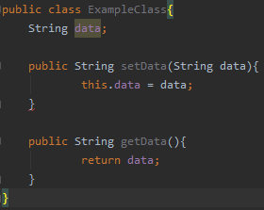

1. Instantiation of an object



1. Visibility



1. Member data
2. Inheritance

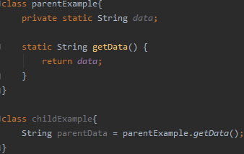

1. Interface

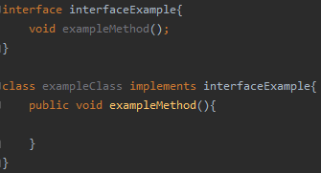

1. Polymorphism
2. Overriding

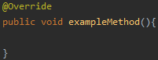

1. Abstract class



# Fundamental concepts

1. What programming languages you can use for Android app development?

-Kotlin, Java and C++

2. What is .apk file?

-APK = android package. It’s a file that has been compiled by SDK tools and it consists of all the code & resources

3. How Android system runs apps?

-Each app runs as their own Linux process.

4. Name four types of Android components. Describe each.

-Activity: what user sees on the screen

-Service: runs in the background to for example get data, keeps the app alive

-Broadcast receiver: allows the app to receive system-wide notifications

-Content provider: allows other apps to access data in the component

5. What is manifest file and what is its purpose?

-Manifest file consists of information about the application: all components, user permissions, minimum API level etc. All of these are needed so that the system to knows what to load.

6. What are resources? Why they are needed?

-Resources are files for styling: layouts, colors, animations etc. They are needed for providing resources -> no hardcoded text for example. Helps in for example translating.